**Pump Master**

A PROJECT REPORT

*Submitted by*

**Abhay H. Manavadariya (19CP026)**

*In partial fulfillment for the award of the degree of*

**B. TECH. in COMPUTER ENGINEERING**

**4CP33: Full Semester External Project (FSEP)**



**BIRLA VISHVAKARMA MAHAVIDYALAYA**

**(ENGINEERING COLLEGE)**

*(An Autonomous Institution)*

**VALLABH VIDYANAGAR**

*Affiliated to*



**GUJARAT TECHNOLOGICAL UNIVERSITY, AHMEDABAD**

**Academic Year: 2022 – 2023**

BVM ENGINEERING COLLEGE, VALLABH VIDYANAGAR-388120

# **APPROVAL SHEET**

The project work entitled “**Pump Master**" carried out by “**Abhay Manavadariya (19CP026)**” is approved for the submission in the course 4CP33, Full Semester External Project (FSEP) for the partial fulfillment for the award of the degree of B. Tech. in Computer Engineering.

Date:

Place:

Signatures of Examiners:

(Names and Affiliations)

**CERTIFICATE**

This is to certify that Project Work embodied in this project report titled “**Pump Master**" was carried out by “**Abhay Manavadariya (19CP026)”** under the course **4CP33, Full Semester External Project** for the partial fulfillment for the award of the degree of B. Tech. in Computer Engineering. Followings are the faculty supervisors at the institute:

Date:

Place:

|  |  |  |
| --- | --- | --- |
| Mr. Jubin Patel | Prof. Narendra M. Patel | Prof. Prashant B. Swadas |
| Director  Emgage HR Simplified!  Ahmedabad | Profressor (CAS)  Computer Engineering Department,  BVM Engineering College, Anand | Associate Professor  Computer Engineering Department,  BVM Engineering College, Anand |

|  |
| --- |
| Dr. Darshak G Thakore |
| Prof. & Head,  Computer Engineering Department,  BVM Engineering College |

COMPUTER ENGINEERING DEPARTMENT, BVM ENGINEERING COLLEGE, VALLABH VIDYANAGAR-388120



DECLARATION OF ORIGINALITY

We hereby certify that we are the sole authors of this report under the course 4CP33 (Full Semester External Project) and that neither any part thereof nor the whole of the report has been submitted for a degree to any other University or Institution.

We certify that, to the best of our knowledge, the current report does not infringe upon anyone’s copyright nor does it violate any proprietary rights and that any ideas, techniques, quotations or any other material from the work of other people included in our report, published or otherwise, are fully acknowledged in accordance with the standard referencing practices. Furthermore, to the extent that we have included copyrighted material that surpasses the boundary of fair dealing within the meaning of the Indian Copyright (Amendment) Act 2012, we certify that we have obtained a written permission from the copyright owner(s) to include such material(s) in the current report and have included copies of such copyright clearances to our appendix.

We declare that this is a true copy of report, including any final revisions, as approved by the report review committee.

We have checked write-up of the present report using anti-plagiarism database and it is in permissible limit. However, at any time in future, in case of any complaint pertaining of plagiarism, we are the sole responsible persons for the same. We also understand that, in case such complaints of plagiarism, as per the University Grants Commission (UGC) norms, the University can even revoke the degree conferred to the students submitting this report.

Date:

Institute Code: 007

Institute Name: Birla Vishvakarma Mahavidyalaya (BVM) Engineering College

|  |
| --- |
| Signature |
| Abhay H. Manavadariya |
| 19CP026 |

# **ACKNOWLEDGEMENT**

We, hereby, would like to take this opportunity to thank all the people who have been involved in helping and assisting us during the entire period.

Firstly, we are grateful to the Computer Engineering Department at B.V.M Engineering College for giving us this opportunity of 8th SEM External Project.

We would like to convey our deepest gratitude to our project guides, Prof. Prashant B. Swades and Prof. Narendra M. Patel and also convener, Prof. Mosin I. Hasan for their kind support, continuous supervision, and for the valuable knowledge that they imparted to us.

We group member are grateful to each other for generous support and encouragement to work rigorously and accompanying each other during the period to achieve the desired outcomes.

Lastly, we would like to thank our friends and other classmates for the encouragement and for being the source of inspiration. We are heartily thankful to our families for constant support. We are grateful that we were given this opportunity.

|  |
| --- |
| Abhay H. Manavadariya |
| 19CP026 |

# **Plagiarism Report**

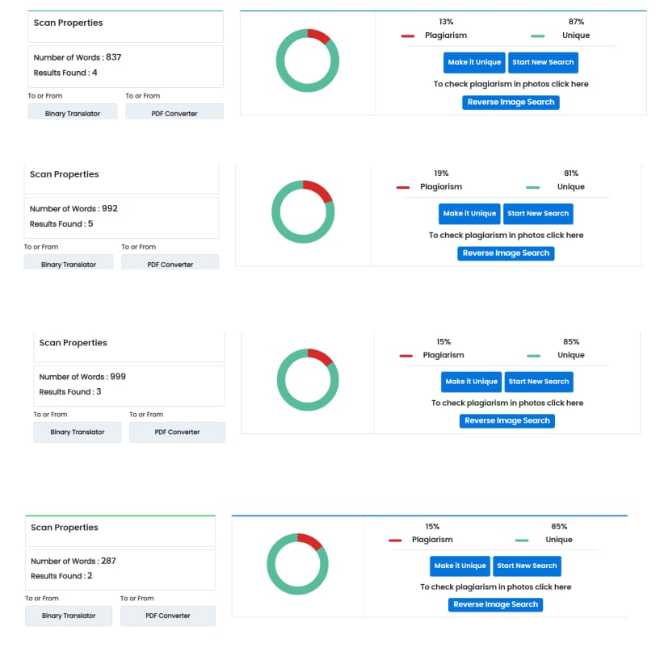

**Abstract**

The petrol pump management system is an advanced software application that is designed to provide a comprehensive solution for managing the day-to-day operations of a petrol pump. The system has been developed to improve the efficiency of petrol pump management by automating various tasks, reducing manual intervention, and streamlining workflows. The system provides an intuitive user interface that allows petrol pump manager to add pump details, add petrol details, track to tank filling data, add worker details, show worker details, rate change of petrol , device firmware and many more features. Overall, the petrol pump management system provides an all-in-one solution for managing petrol pump operations efficiently and effectively, leading to increased productivity and improved customer satisfaction.

TABLE OF CONTENTS

APPROVAL SHEET...................................................................................................................... II CERTIFICATE...............................................................................................................................III ACKNOWLEDGEMENT ............................................................................................................. V Plagiarism Report.........................................................................................................................VI ABSTRACT....................................................................................................................................VITABLE OF CONTENTS................................................................................................................IX LIST OF FIGURES .......................................................................................................................XI

1. Introduction ............................................................................................................................. 1

1.1 Application Overview...................................................................................................................1 1.2 Objective .....................................................................................................................................1 1.3 Moules........................................................................................................................................1 1.3.1 Refresh Inbox............................................................................................................................1 1.3.2 Add Email account................................................................................................................1 1.3.3 Remainder Emails.................................................................................................................1 1.3.4 Recent Emails .......................................................................................................................1 1.3.5 Set date-wise alert .................................................................................................................1 1.3.6 Check date-wise alert............................................................................................................1 1.4 Intended Use .............................................................................................................................2 1.5 Technical Requirments................................................................................................................2

2. Tools And Technologies.......................................................................................................... 3 2.1

2.1 Hardware Requirements :-..........................................................................................................3 2.2 Software Requirements :-...........................................................................................................3

3. Modeling and Design............................................................................................................... 8

3.1 ER Diagram :-.............................................................................................................................8 3.2 Flow Chart :-..............................................................................................................................9 3.3 Data-Flow Diagram :-...............................................................................................................10 3.4 Use Case Diagram :-.................................................................................................................13 3.5 TimelineChart :-.........................................................................................................................14

4. Implementation...................................................................................................................... 15

4.1 Moules.......................................................................................................................................15 4.2Snashots....................................................................................................................................16

5. Conclusion and Future scope................................................................................................. 29 5.1 Conclusion ..............................................................................................................................29 5.2 Future Scope ............................................................................................................................29

REFERENCES ............................................................................................................................. 3

# **List of Figures**

Figure 2.1 Spring Boot Architecture

Figure 2.2 Hibernate Architecture

Figure 2.3 PostgreSQL Architecture

Figure 3.1 ER Diagram

Figure 3.2 Flow Chart

Figure 3.3 Use-Case Diagram

Figure 3.4 Timeline Chart

Figure 4.2.1 Signup Page

Figure 4.2.2 Sign in Page

Figure 4.2.3 Home Page

Figure 4.2.4 Add

Figure 4.2.5 Add Pump

Figure 4.2.6 Add new Stock

Figure 4.2.7 Tank Filling Data

Figure 4.2.8 Add Worker Details

Figure 4.2.10 Device Raw Data

Figure 4.2.11 Rate Change

Figure 4.2.12 Device Firmware

Figure 4.2.13 Add Device Firmware

Figure 4.2.14 Pump Dashboard

# **Introduction**

* 1. Application Overview

Pump Master will provide user to make their life a bit easy in the aspect of handling multiple petrol pumps and bit easy to track petrol filling data.

* 1. Objective

The major objective of the project is to build web-based application that would provide resource management like handling different petrol pumps at one place and addition to that track of petrol filling data and many features.

* 1. Modules

1.3.1 Add Petrol Pumps Details

1.3.2 Add Petrol New Stock

1.3.3 Add Worker Details

1.3.4 Device Firmware

1.3.5 Device Raw Data

1.3.6 Rate Change

* + 1. Add Petrol Pumps Details

This tabs add the all newly petrol pump details in the system. With this module, admin can create a new petrol pump by entering details such as the name, no of nozzle, storage capacity and stop pump event.

* + 1. Add Petrol New Stock

This tabs add the new stock of petrol. With this module, admin can track the details of tank filling data.

* + 1. Add Worker Details

This tabs add the worker details in specific petrol pump like how many workers working in the petrol pump. Using this module, admin can easily see the worker details.

* + 1. Device Firmware

Basically Firmware acts as a bridge between the hardware and the higher-level software, enabling them to communicate with each other. So using this module, admin can communicate with the device, if admin want to stop dispense then using these module admin can send the command to the device.

* + 1. Device Raw Data

This tabs shows the data that gives from the device.

* + 1. Rate Change

This tabs change the rate of petrol.

1.4 Intended Use

This application is intended to be used by all the types of person who has manage multiple petrol pump and a person who has keep to track of all details such as petrol filling data, worker details etc.

1.5 Technical Requirements

This section lists technical requirements.

Java, Spring Boot, Hibernet :- Backend

React.js :-Frontend

Bootstrap :- Frontend toolkit

PostgreSQL : Database

1. **Tools And Technologies**

2.1 Hardware Requirements :-

* Processor = internal core i5 or above
* RAM = 4GB above
* Hard disk = 50GB or above

2.2 Software Requirements :-

* FrontEnd = HTML, CSS, Bootstrap, React.js
* Backend = Java, Hibernet, Spring Boot
* Database = Postgresql

2.2.1 FrontEnd :-

* HTML - HTML (Hypertext Markup Language) is a text-based approach to describing how content contained within an HTML file is structured. This markup tells a web browser how to display text, images and other forms of multimedia on a webpage.

HTML is a formal recommendation by the World Wide Web Consortium (W3C) and is generally adhered to by all major web browsers, including both desktop and mobile web browsers. HTML5 is the latest version of the specification.

* CSS - Cascading Style Sheets, fondly referred to as CSS, is a simple design language intended to simplify the process of making web pages presentable.

CSS handles the look and feel part of a web page. Using CSS, you can control the color of the text, the style of fonts, the spacing between paragraphs, how columns are sized and laid out, what background images or colors are used, layout designs,variations in display for different devices and screen sizes as well as a variety of other effects.

CSS is easy to learn and understand but it provides powerful control over the presentation of an HTML document. Most commonly, CSS is combined with the markup languages HTML or XHTML.

* Bootstrap - Bootstrap is a [free, open source](https://www.techtarget.com/whatis/definition/Free-and-open-source-software-FOSS-or-free-libre-open-source-software-FLOSS) [front-end](https://www.techtarget.com/whatis/definition/front-end) development framework for the creation of websites and web apps. Designed to enable [responsive](https://www.techtarget.com/whatis/definition/responsive-design) development of [mobile-first](https://www.techtarget.com/searchmobilecomputing/definition/mobile-first) websites, Bootstrap provides a collection of syntax for template designs.As a framework, Bootstrap includes the basics for responsive web development, so developers only need to insert the code into a pre-defined grid system. The [Bootstrap framework](https://www.theserverside.com/quiz/12-tough-Bootstrap-5-quiz-questions-for-web-developers) is built on Hypertext Markup Language ([HTML](https://www.theserverside.com/definition/HTML-Hypertext-Markup-Language)), cascading style sheets ([CSS](https://www.theserverside.com/definition/cascading-style-sheet-CSS)) and [JavaScript](https://www.theserverside.com/definition/JavaScript). Web developers using Bootstrap can build websites much faster without spending time worrying about basic commands and functions.
* React.js - React.js, commonly known as React, is an open-source JavaScript library for building user interfaces. It was developed by Facebook and is widely used for developing web applications, particularly single-page applications and mobile applications.
* React follows a component-based architecture, which means that applications are built by breaking down the UI into smaller reusable components. Each component represents a piece of the UI and is responsible for its own rendering and behavior. Components can be combined to build complex UIs, and changes to one component are automatically reflected in any other components that depend on it.
* React uses a virtual DOM (Document Object Model), which is a lightweight copy of the actual DOM. The virtual DOM allows React to efficiently update the UI without having to re-render the entire page. Instead, React only updates the parts of the UI that have changed, resulting in faster and more efficient performance.

2.2.2 Backend :-

* Java – Java is a high-level, object-oriented programming language that is widely used for developing web, mobile, and desktop applications. It was developed by Sun Microsystems and was later acquired by Oracle Corporation. Java is platform-independent, which means that once compiled, Java code can run on any system that has a Java Virtual Machine (JVM) installed.
* Java has automatic memory management through garbage collection.
* Java is known for its security features, including sandboxing and bytecode verification.
* Java is a strongly typed language with a rich set of data types.
* Java is popular in the enterprise world for building large-scale, mission-critical applications.
* Spring Boot -Spring Boot is an open-source framework for building web applications in Java. It is built on top of the Spring Framework and provides a simplified and opinionated approach to configuring and deploying Spring-based applications.
* Spring Boot aims to make it easier and faster to develop production-ready applications by providing a pre-configured environment with sensible defaults. It also provides a set of starter dependencies, which are pre-configured sets of commonly used libraries, that can be easily added to a project to provide additional functionality.

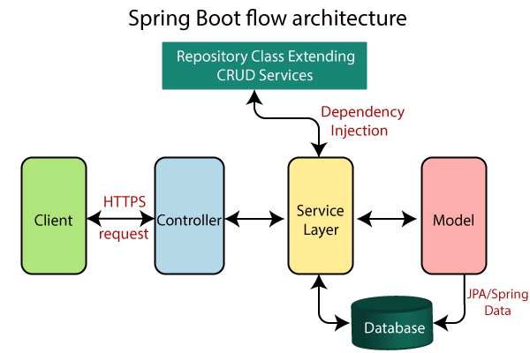

2.1 Spring Boot Architecture

* Hibernet - Hibernate is an open-source object-relational mapping (ORM) framework for Java. It provides a way to map Java objects to database tables and provides a bridge between the object-oriented programming world and the relational database world.
* Hibernate simplifies the process of persisting data in a database by providing an easy-to-use and flexible API. It allows developers to write database queries using object-oriented syntax and provides a high-level abstraction layer over SQL.

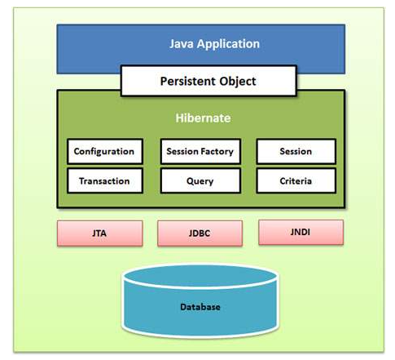

2.2 Hibernate Architecture

* PostgreSQL - PostgreSQL is a powerful, open-source object-relational database management system (ORDBMS) that is widely used for enterprise applications, web applications, and data analytics. It is known for its scalability, performance, and robustness.
* PostgreSQL is an ACID-compliant database, which means that it provides a high level of data consistency and reliability. It supports a wide range of data types, including text, numeric, date/time, and JSON, and includes advanced features such as full-text search, GIS, and support for multi-version concurrency control (MVCC).

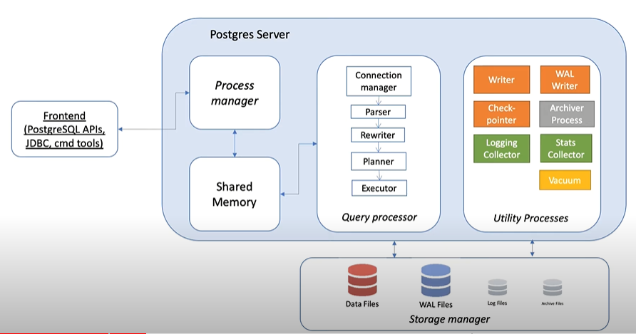

2.3 PostgreSQL Architecture

1. **Modeling and Design**

3.1 ER Diagram :-

ER Diagram stands for Entity Relationship Diagram, also known as ERD is a diagram that displays the relationship of entity sets stored in a database.

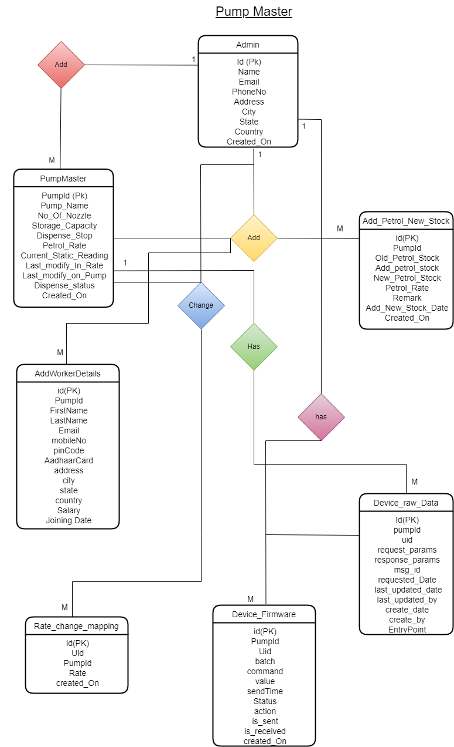

3.1 ER Diagram

3.2 Flow Chart ;-

A flowchart is a diagram that depicts a process, system or computer algorithm. It represents a workflow.

A flowchart is simply a graphical representation of steps. It shows steps in sequential order and is widely used in presenting the flow of algorithms, workflow or processes.

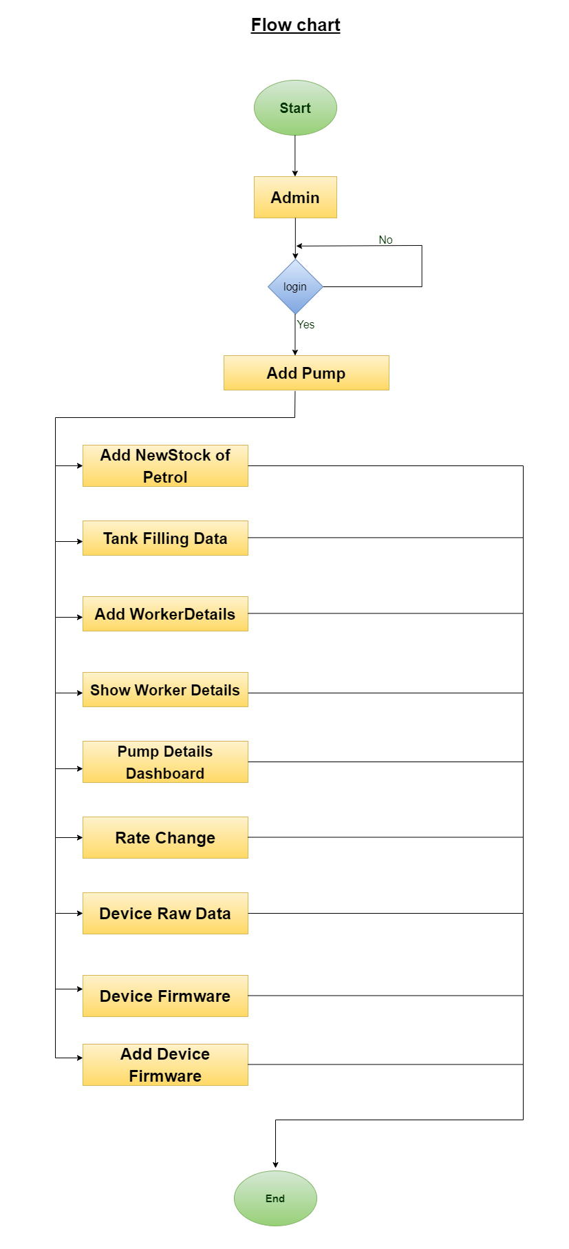

3.2 Flow Chart

3.3 Use Case Diagram :-

A use case is a methodology used in system analysis to identify, clarify and organize system requirements.

Here, in this diagram one actor is there is called Admin. There are a total of nine use cases that represent the specific functionality of a pump master. admin can login in the system , can add pump details, can add new stock of petrol, can show petrol filling details, can change rate, can show particular pump dashboard, can add worker details, can show worker details.

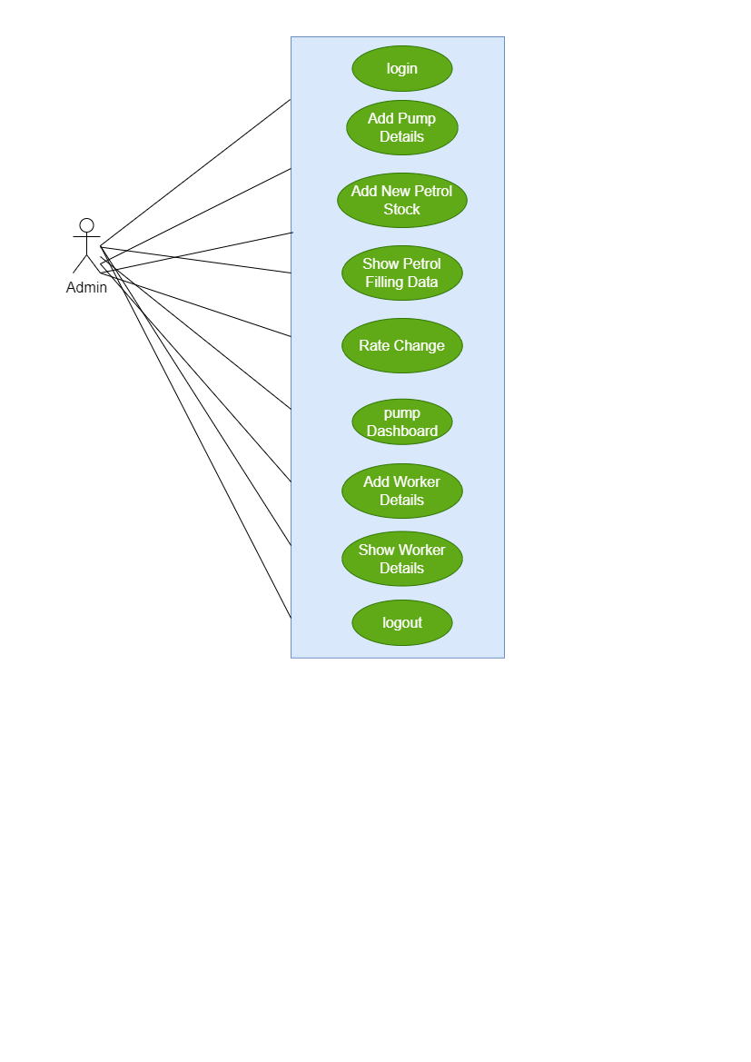

Figure 3.3 Use-Case Diagram

3.4 Timeline Chart :-

Timeline is a chart that depicts how a set of resources are used over time.

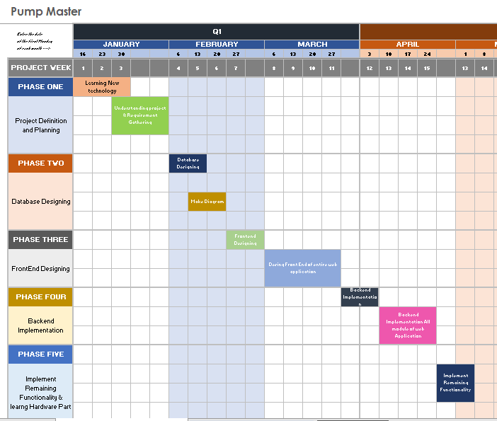

Figure 3.4 Timeline Chart

1. **Implementation**

This section demonstrates the working of the project. It also has the information about the module included in the project. And lastly has snapshots of the project.

4.1 Modules

4.1.1 Admin module

1. Signup page

Create Admin account.

1. Signin page

Login to the system by email id and password,

1. Dashboard

Show fuel sale data and pump master dashboards.

1. Pump Dashboard

In this tab, can show all the details regarding particular pump like how many liter of petrol currently, rate change date and total nozzle, dispensing status.

1. Add

In this tab, show add pump and add new stock button.

1. Add New Pump

In this section, Admin can input new pump details such as how many nozzles are in the pump, how many liters of petrol you want to stop pouring from the nozzle, and other information.

1. Add New Stock Of pump

In this, Admin can track of new stock details of petrol.

1. Add Worker details

In this tab, Admin can enter the particular worker details.

1. Device Raw data

In this tab, Admin can see the raw data that are coming from the device.

1. Rate Change

Admin can change the petrol rate from this tab and track the record of rate change.

**4.2 Snapshots**

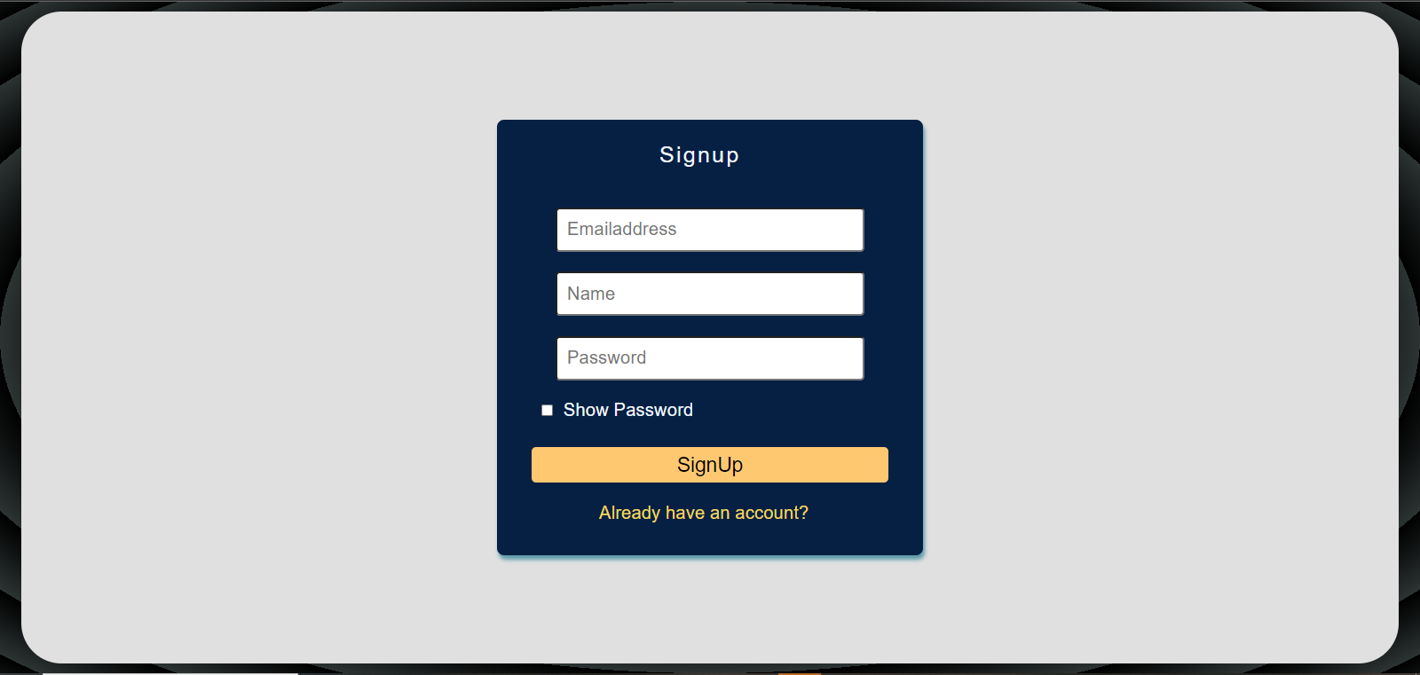

4.2.1 Signup Page

After providing the necessary information on the sign-up page, Admin can sign up.

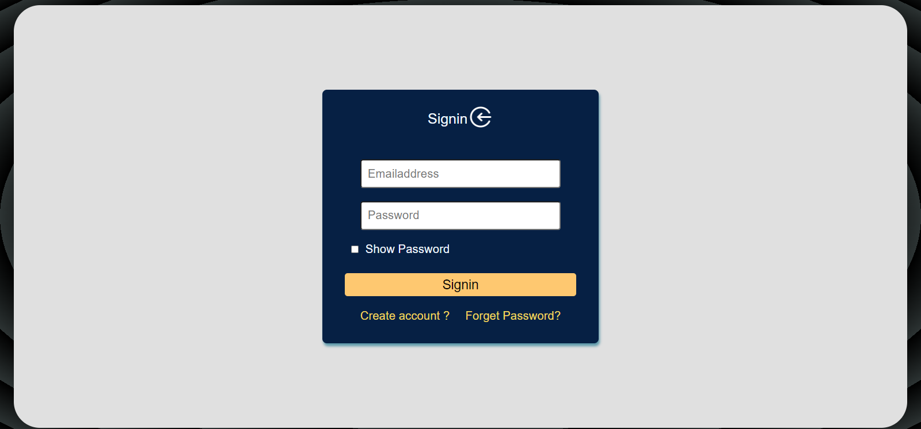

4.2.2 Sign in Page

After filling correct details Admin navigate to home page.

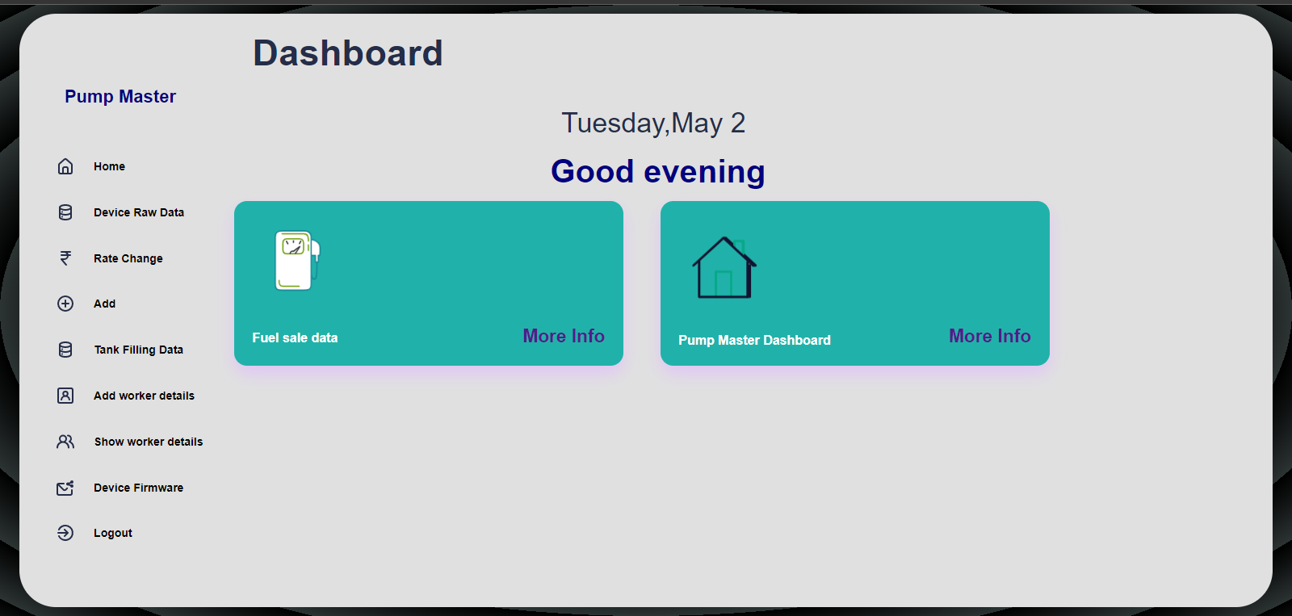

4.2.3 Home Page

Dashboard page show fuel sale data Tab and Pump Master Dashboard Tab.

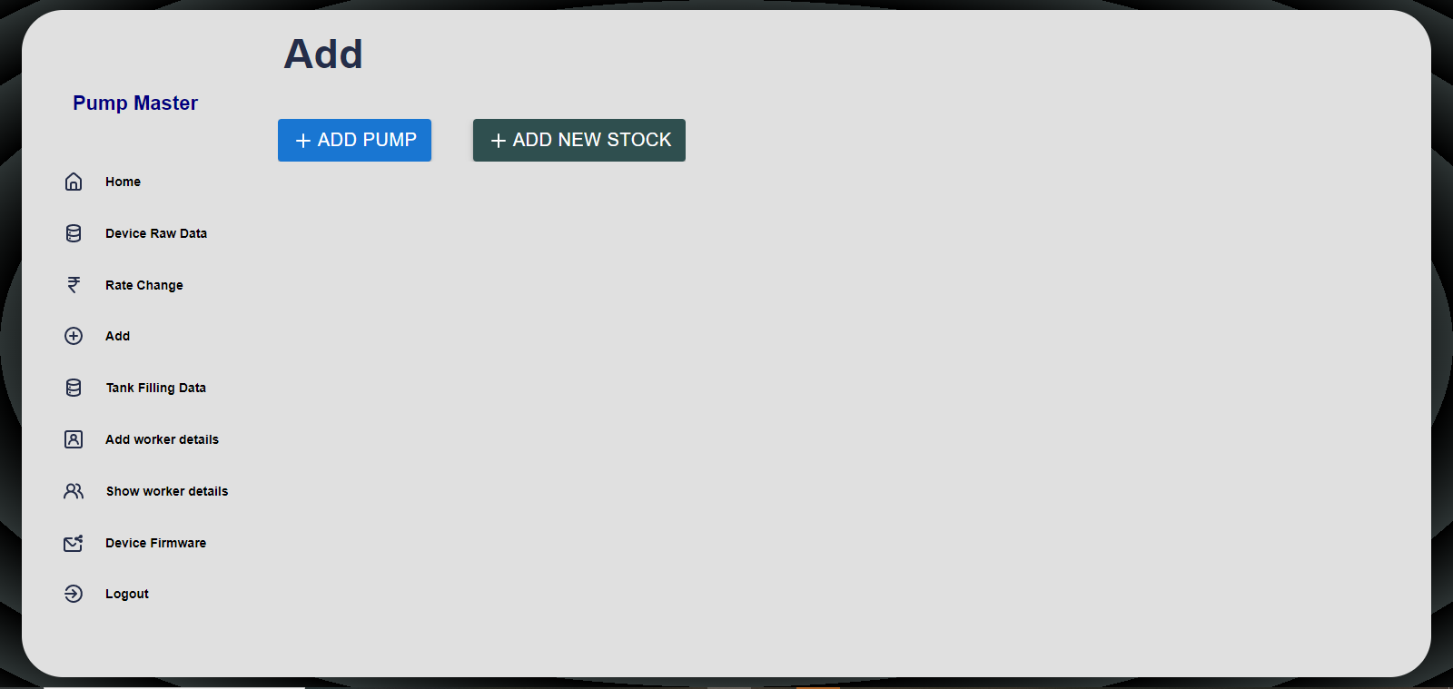

4.2.4 Add

This is an Add tab where the administrator can enter Add Pump Details as well as Add New Stock Of Petrol. When the administrator clicks on the Add Pump button in this tab, a new popup box will appear where they can enter all of their information. When you click on Add New Stock Date, a new popup box will appear where you can enter all of your information.

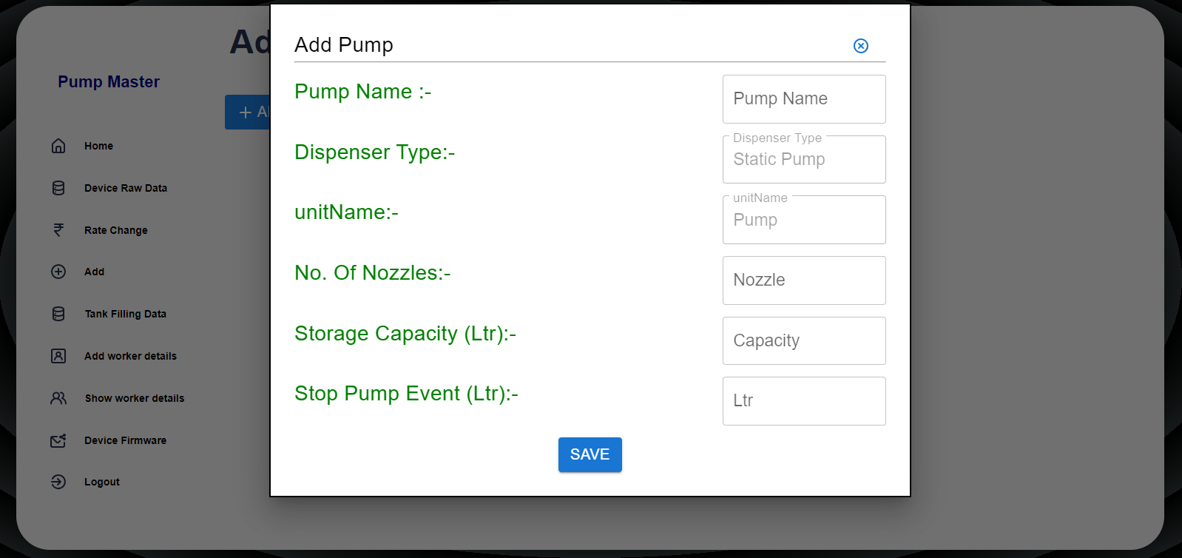

4.2.5 Add Pump

This is a Add pump popup box where admin can add new petrol pump details like pump name, dispenser type, no of nozzles, storage capacity and stop pump event like How many liters of petrol should the dispenser stop. So, all these details admin can enter while new Add Pump.

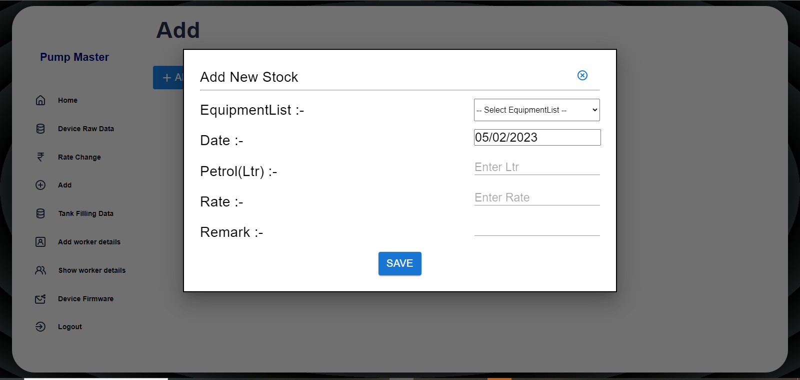

4.2.6 Add new Stock

This is an Add New Stock Popup Box where admin may add new petrol stock such as the date new stock was added, the number of liters of petrol added, and the rate at a specific moment. As a result, these details were included while entering new petrol stock details.

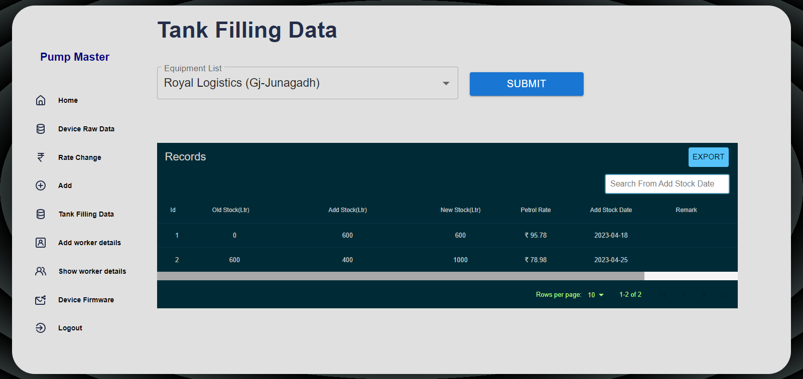

4.2.7 Tank Filling Data

In this Tab, Admin can see the all the details of petrol tank filling data and filter data accordingly and generate excel sheet of that data.

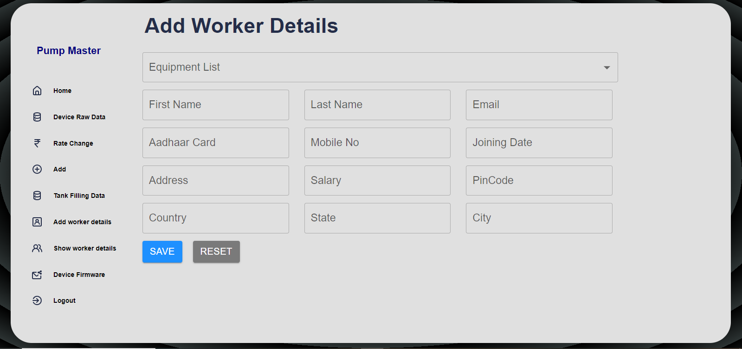

4.2.8 Add Worker Details

In this tab, the administrator can enter the worker details for a specific petrol pump and fill in all the details; if any details are missing, a toast message will be displayed.

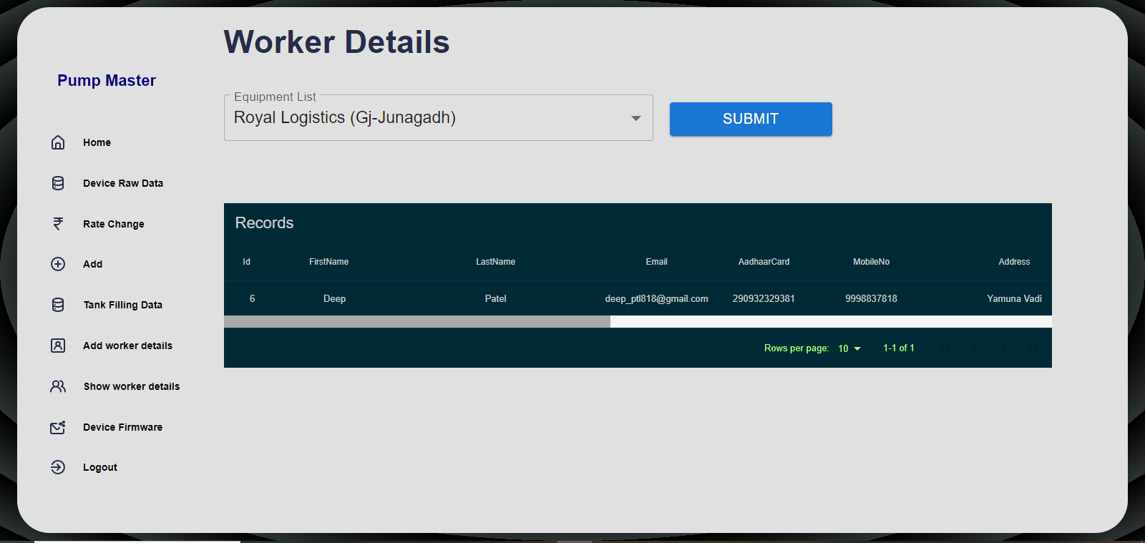

4.2.9 Show Worker Details

In this tab, Admin can show the worker details of that particular pump.

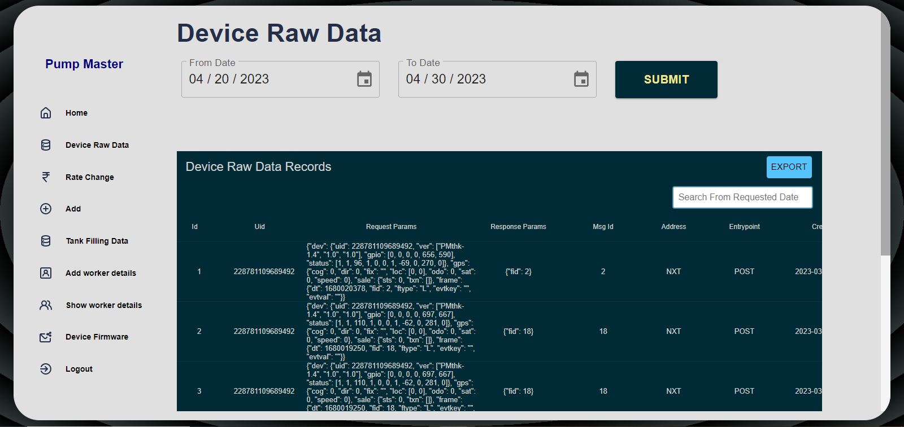

4.2.10 Device Raw Data

In this Device Raw Data, Admin can show the data which are came from the Devices. Search the data from the date and generate Excel of that data.

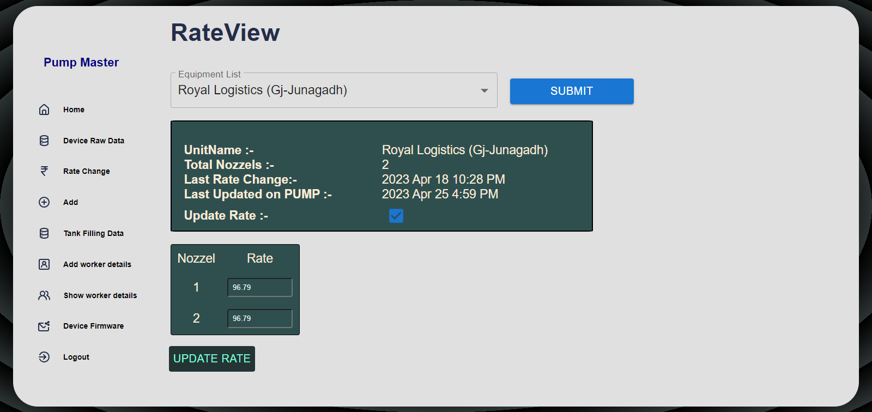

4.2.11 Rate Change

From this Tab, Admin can change the petrol rate and below Rate input box will be only enabled when update Rate Checkbox is checked.

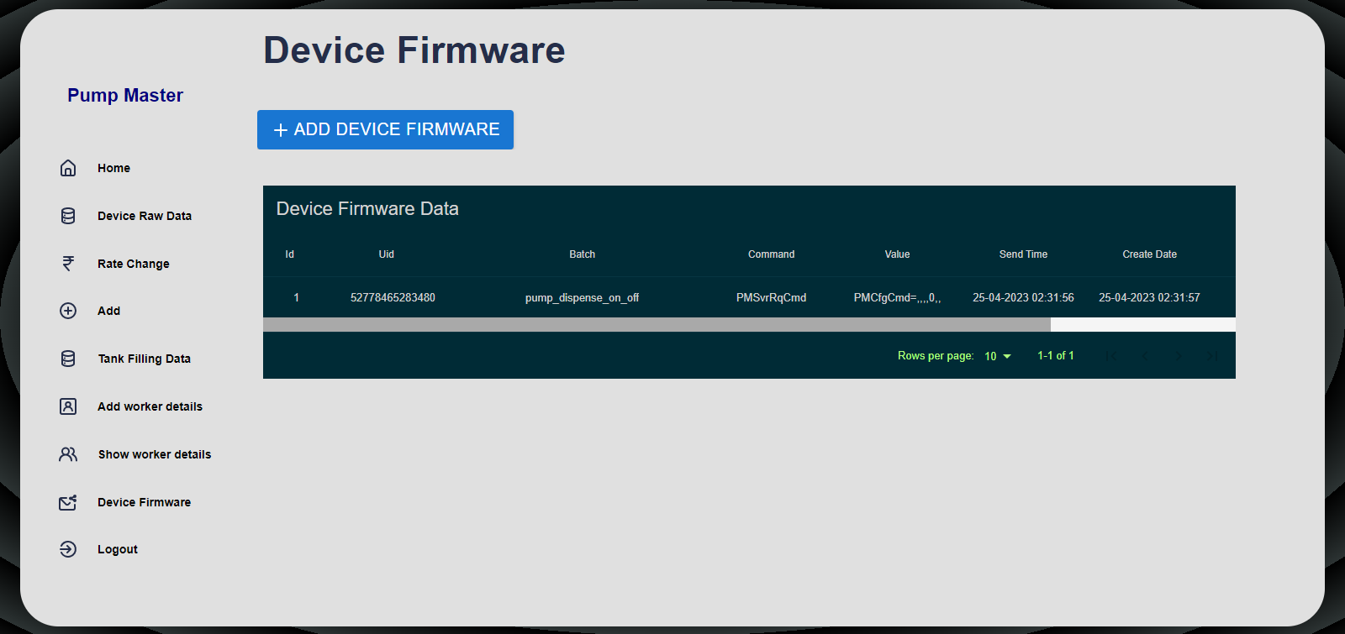

4.2.12 Device Firmware

In this tab, the administrator give a command to a specific device, and the table below shows the details as well as when the command is received by the device and its status.

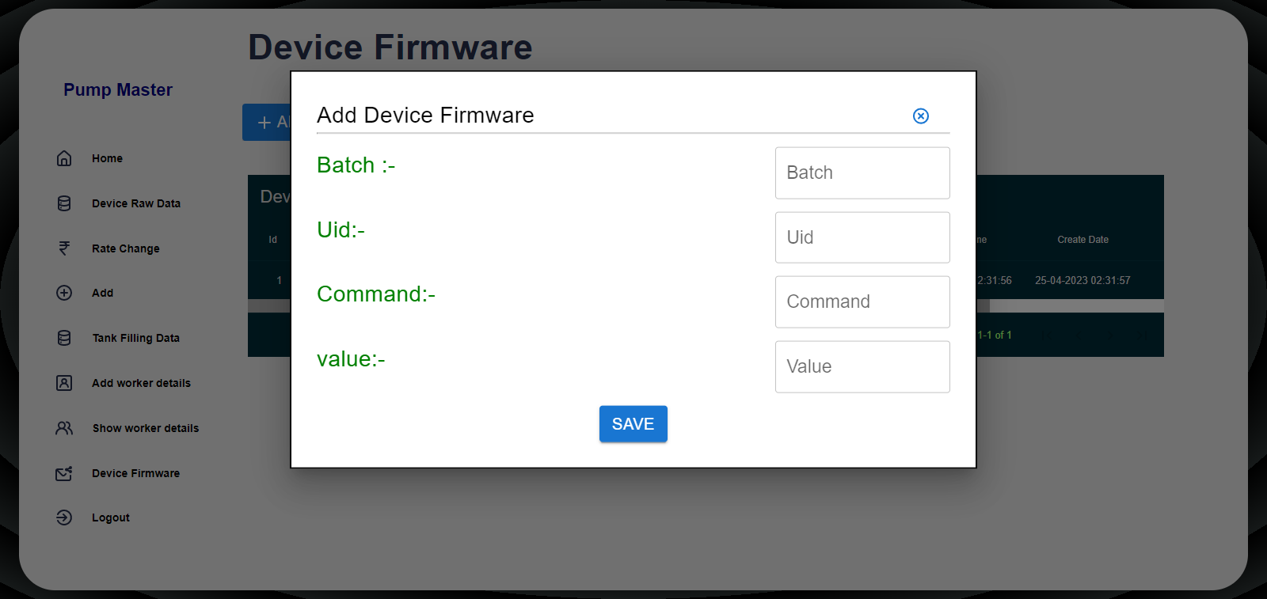

4.2.13 Add Device Firmware

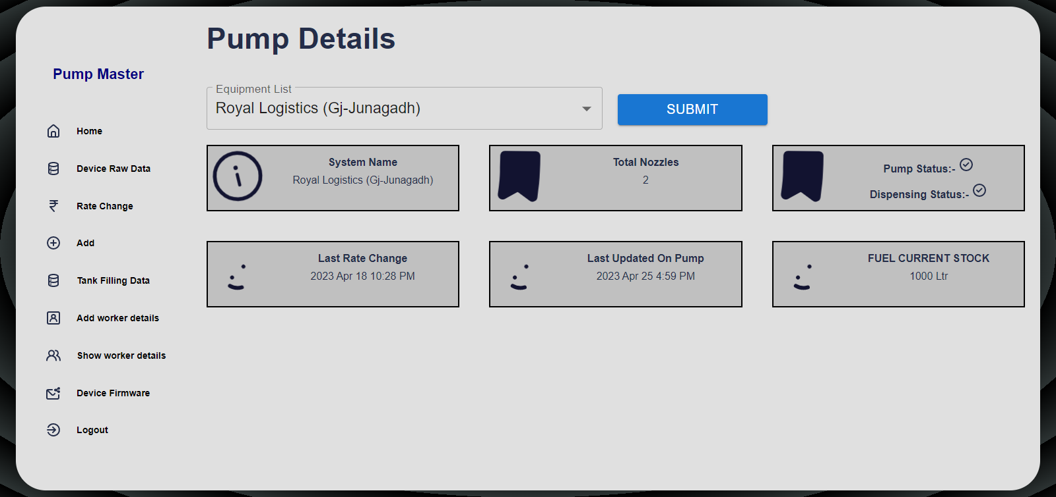

4.2.14 Pump Dashboard

In this Dashboard, Admin can see all the details regarding pump

1. **Conclusion and Future scope**

Last but not the least is the CONCLUSION part which gives overall review of the project. Here are also mentioned some of the future scopes of the project which can be further implemented.

**5.1 Conclusion**

The Pump Master is a web application which will manage All petrol pump details very efficiently.

In conclusion, we have successfully developed a Pump master web application that provides a user-friendly platform for managing petrol pumps. During the development process, we encountered various challenges, such as designing an intuitive user interface and ensuring the security of user data.

Overall, we are satisfied with the outcome of our project and believe that it can who has many petrol pumps as well as the people or organization who manage the petrol pump details. However, there is still room for improvement in terms of adding more options like fuel sale data tab then Role page and integrate with device.

Our hope is that our work can serve as a starting point for others who are interested in improving this web application. With further development and implementation, we believe our system can have a positive impact on the industry.

**5.2 Future Scope**

Integration with other cool features: In the future, we can add more features to our system. For example, we could integrate with hardware device and get the data from the device. Other things that we have planned of track the data of fuel selling then one more feature is role and permission.

* UI modifications
* Integrate with hardware and getting data from the device
* Fuel Sale Data
* Role
* Reports

**REFERENCES**

[1] HTML :- [w3schools](https://www.w3schools.com/html/)

[2] CSS :- [w3schools](https://www.w3schools.com/css)

[3] JavaScript :- [JavaScript | MDN (mozilla.org)](https://developer.mozilla.org/en-US/docs/Web/javascript)

[4] React.js :- [Quick Start – React](https://react.dev/learn)

[5] Redux Library :- [Getting Started with Redux | Redux](https://redux.js.org/introduction/getting-started)

[6] Spring Boot :- [Spring Boot](https://spring.io/projects/spring-boot)

[7] Hibernate :- [Learn Hibernate Tutorial - javatpoint](https://www.javatpoint.com/hibernate-tutorial)

[8] PostgreSQL :- [Learn PostgreSQL Tutorial - javatpoint](https://www.javatpoint.com/postgresql-tutorial)

[9] iconscout :- [iconscout](https://iconscout.com/unicons)